MovieCo

Description: When you have andaccount on the MovieCo app, you can look at a library of movies and look at all of the information about that movie. You can personalise your account with styling and personal information. You can also add movies to your library and save them.

Story 1: Creating account:
As a user
I’m able to create an account
So I can log in
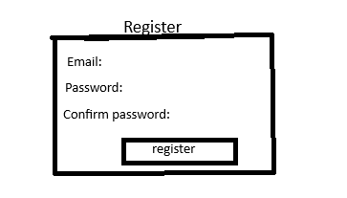
-People can fill in their data
-You have to be able to create the account
- If someone’s data does not fit the basic requirements it gives an error

Story 2: Logging in:
As a user
I am able to log in
So I can access my account

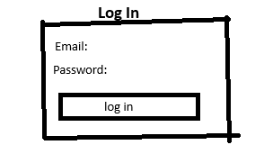
- People can fill in their account details
- People can log in
- If someone’s data is incorrect it gives an error

Story 3: Home page:
As a User
I am able to have a home page and see the information about the website
So I can inform myself about the website
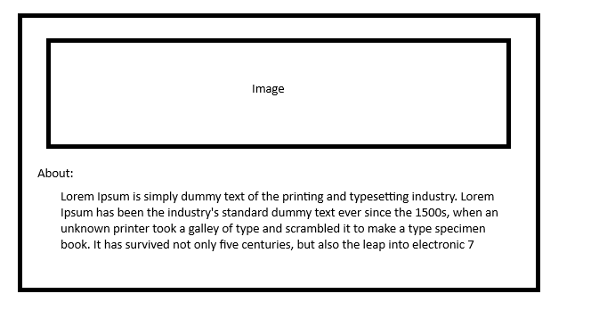
- People can see the image
- people can see the about text

Story 4: Navigation bar:
As a User
I am able to go to different pages
So I can use the whole website
-All the pages are clickable and go to the correct pages

Story 5: Movies page:
As a User
I am able to see all the movies
So I can pick and look at the movies

-All movies should show up
- They should all align well

Story 6: Movies information page:
As a User
I am able to click on a movie and see all the information about that movie
So I can inform myself about the movie
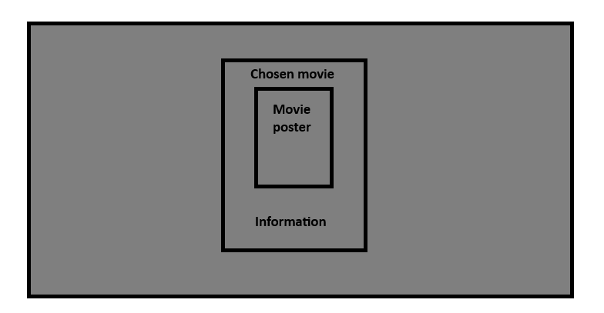
- It should be a popup on top of the other movies
- It should display the title, movie poster, actors
- It should work for all movies

Story 7: Personal movie library:
As a user
I am able to save my favourite movies to a personal library
So I can remember all my favourite movies and find all the information about them easily


- You should be able to add a movie to the library
- You should be able to delete movies from your library

Domain model :
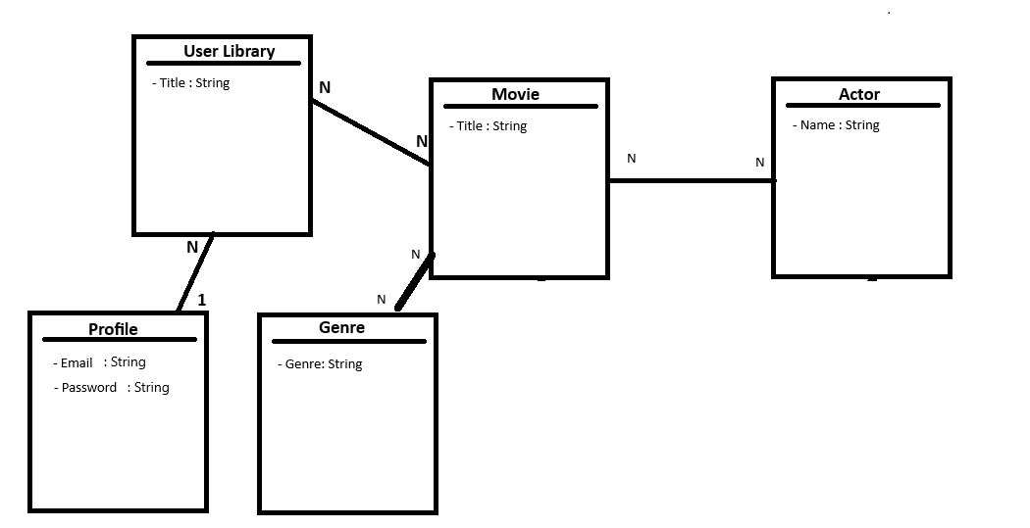

Conceptual Model :
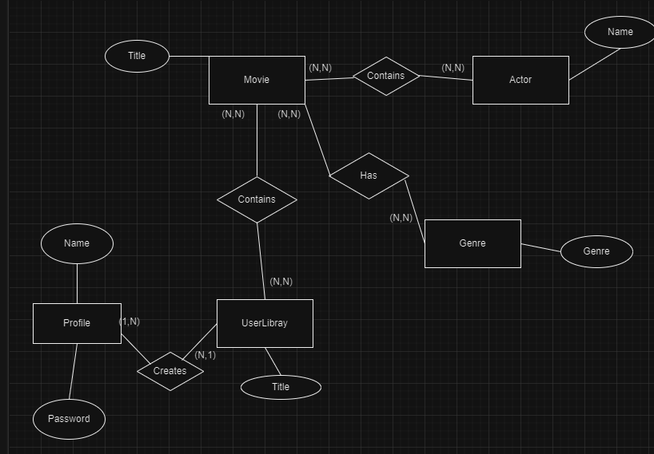

Logical model :
